
Groupe 9
Technical Report
Manuel LEITAO, Quentin SAUNER, Lucas FULCRAND, Lucas LORET, Johan LANÇON

02/05/2023
Table of contents
1 AI strategy 2
1.1 Random AI 2
1.1.1 Description 2
1.1.2 Computer assessment 2
1.1.3 Effectiveness assessment 2
1.2 Intelligent AI 1 2
1.2.1 Description 2
1.2.2 Computer assessment 2
1.2.3 Effectiveness assessment 2
1.3 Intelligent AI 2 2
1.3.1 Description 2
1.3.2 Computer assessment 2
1.3.3 Effectiveness assessment 2
2 The various input files 2

AI strategy

Random AI

Description
This is a random AI, it was used initially before the creation of the other AI.

Computer assessment
une évaluation "informatique" de leur performance (volume de code, mémoire utilisée, temps d'exécution moyen, …) The average execution time of this AI is 5948 ms.

Effectiveness assessment
This AI is very inefficient, it wins 0,5% of these games.

Intelligent AI 1

Description
First, the current color is initialized to 1. Then, the IA an attempt by searching for the presence of the current color and counting the number of occurrences of that color in the combination. This attempt is submitted to the program that generates the combination to get the number of well placed and misplaced balls.
Then, the IA determines the number of occurrences of the current color using the formula: nbOccurences = nbWellPlaced - nbBallAlreadyWellPlace. If the current color is present in the combination, the IA scans each occurrence of that color and generates a new attempt by searching for the exact position of that color, using the second criterion. This attempt is submitted to the program that generates the combination to get the number of misplaced balls. This step repeats as long as the number of misplaced balls is different from 0, which means that there are still misplaced balls for this color.
Finally, the current color is incremented by 1 and the IA repeats this process until the combination is resolved. This combination is considered resolved when the number of well placed balls is equal to the total number of balls in the combination

Computer assessment
The average execution time of this AI is 5873 ms and the code uses a volume of 6.9 Kb.
une évaluation "informatique" de leur performance (volume de code, mémoire utilisée, temps d'exécution moyen, …)

Effectiveness assessment
This AI is a bit effective, it wins 58% of these games. This AI cannot make optimum use of the information provided after each attempt, it merely systematically applies the heuristic criteria, which can lead to less effective results than more sophisticated approaches.

Intelligent AI 2

Description
It starts by initializing the current color to 1, then generates an attempt to find the presence and number of occurrences of the current color, submits this attempt to the program to recover the number of balls placed and misplaced. Then, it determines the number of occurrences of the current color using a formula. If the current color is present in the combination, it generates an attempt to find the exact position of the current color.
Using several criteria, it determines the number of occurrences of the next color. If the next color is not in the combination, it selects it. It then continues to generate attempts until the number of misplaced balls equals 0. The next color is then selected, and the process starts again. This IA is very effective, but it still has its limits because of the expectation of satisfaction of one constraint before moving on to another.

Computer assessment
une évaluation "informatique" de leur performance (volume de code, mémoire utilisée, temps d'exécution moyen, …) The average execution time of this AI is 4944 ms and the code uses a volume of 9,8 Kb.

Effectiveness assessment
This AI is very effective, it wins 99% of these games. This AI analyses the responses provided by the program after each attempt to adjust its strategy to maximize the information obtained at each stage. This means it uses an iterative approach that gradually reduces the search space until it finds the right combination.

The various input files
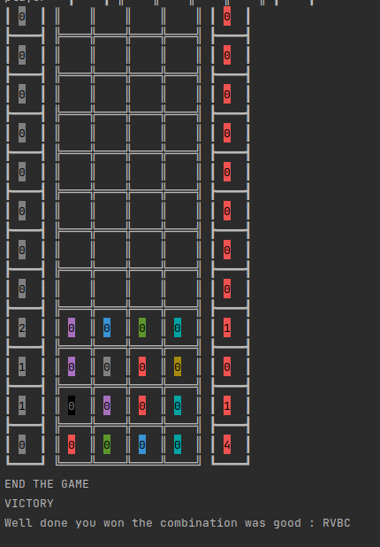
- file_test_correct.txt
RVBC
PBVC
PWRJ
NPRC
RVBC
With this input file everything works well.

- file_test_error_synthaxe1
PBBB
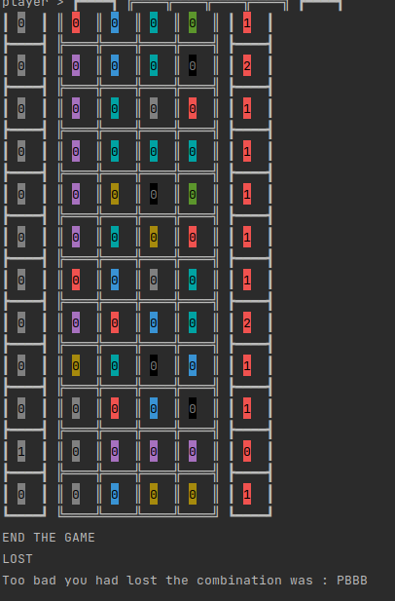
RBCV
PBCN
PCWR
PCCC
PJNV
PCJR
RBWC
PRBC
JCNB
WRBN
WPPP
WBJJ
With this input file the game is lost.

- file_test_error_synthaxe2_win
PPPP
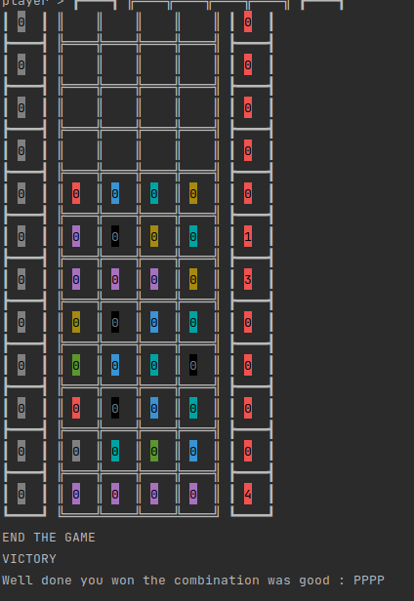
RBCJ
PNJC
mloh
PPPJ
JNBC
VBCN
RNBC
WCVB
bncv
PPPP
With this input file the game is won but there are errors on lines 4 and 10

- file_test_error_synthaxe3_loose
RRRR
CVBN
+++°
dsgjvcxdgnvedgZUDEHDCUFSDHRTFJHY
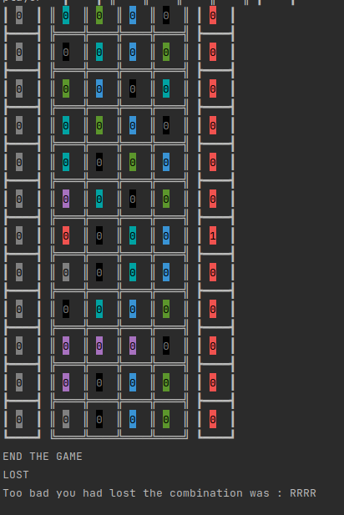
NCBV
VBNC
CVBN
CNVB
PCNV
RNCB
WNCB
NCBV
PPPN
PNBV
WNBV
With this input file the game is lost but there are errors in lines 3 and 4

